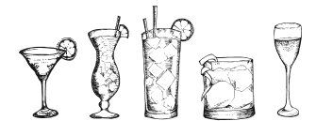
Dry Martini, Whiskey Sour, Negroni, Bellini, Amaretto Sour
119:-

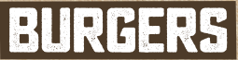

Our burgers are handmade by eco friendly, hanged and tenderized minced beef from Swedish farms. A single burger is 170 grams and served with our own home baked bread, lettuce,. You can compliment your order with sides and sauces.
All of our burgers are served medium/well. Please let your waiter/waitress know if you prefer your burger served well done.
Våra hamburgare kommer från Svenska gårdar och är gjord på välhängd högrev och väger 170 gram. Till alla hamburgare serverar vi vårt egna hamburgerbröd, sallad. Komplettera gärna Era hamburgare med sidorders och någon av våra goda såser. Vi serverar hamburgarna medium/väl eller välstekt.

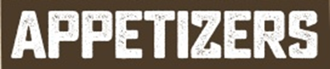

Beer and Burgers combo starter 2/4 pers
Nachos with cheddar cheese and jalapeno, buffalo wings, garlicbread and chili cheese.
Gratinerade nachos med cheddarost och jalapenos, buffalo wings, Vitlöksbröd, Chili cheese
168:-/336:-

Barbeque buffalo wings
Served with blue cheese dip and celery
Buffalo wings, serveras med blue cheesedipp och selleri
98:-

Garlic bread
Vitlöksbröd.
49:-

Nachos with cheddar cheese and jalapenos (2 p)
Gratinerade nachos med cheddarost och jalapenos
89:-

- The Big Guns  Chipotledressing, pepperjack cheese, porkbelly, roasted onion.  Chipotledressing, pepperjack ost, fläsksida samt rostad lök  - The cheeseburger  Mustard, Ketchup, Onion, Pickles, Cheddar cheese  Senap, Ketchup, Gul lök, Inlagd gurka, Cheddarost.  - The Uncle Sam  Cheddarcheese, Ketchuprelisch, Bacon.  Cheddarost, Ketchuprelisch, Bacon  - The One  Applechutney, Aged cheddar, Bacon  Äpplechutney, Lagrad cheddar, Bacon.  - The Kraut  Mayonnaise, Sauerkraut, Slowcooked porkbelly, Smoked cheddarcheese  Majonnäs, Surkål, Nattbakad fläsksida, Rökt cheddarost.  - The Domino  BBQ sauce, Premium bacon, Fried egg, Roasted onion, Cheddar  BBQ sås, Premium bacon, stekt ägg, Rostad lök, Cheddarost  135;-  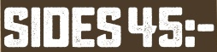  Country style french fries | Country style Pommes Frites  Sweet potato fries | Sötpotatis pommes frites  Beer battered onion rings | Ölpanerad lökring  Side salad | Blandsallad  Peder´s seasoned fries, Sticky fries  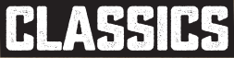  Entrecôte  Served with country style french fries,  Bearnaise sauce and Sauted vegetables.  Grillad Entrecôte med country style pommes frites, Bearnaisesås och Sauterade grönsaker.  265:-  Our famous BBQ-ribs  Served with coleslaw, Country style french fries.  Serveras med coleslaw, Country style pommes frites.  185:- | - The Chili  Chilirelisch, Chili Cheese, Fried Chili  Chilirelisch, Boxholms chiliost, Friterad Chili.  - The Boss  Serranoham, Cheddarcheese, Whipped basil & feta, tomato.  Lufttorkad skinka, Cheddarost, Tomat, Basilika & Fetaostkräm.  - The Oxford Street  Lemonmayaonnaise, Breaded chicken, Crispy bacon  Citronmajonnäs, Pankopanerad kyckling, Knaperstekt Bacon  - The Vegetarian  Halloumi, .Pickled root vegetables, Tzatsiki  Halloumi, Picklade rotsaker, Tzatsiki  - The Nautical  Salmon, Green chili, Terragon, Lime.  Pickled root vegetables, soya creme.  Lax, Grön chili, Dragon, Lime. Serveras med picklade rotsaker samt soja kräm.  135;-  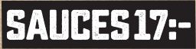  Blue cheese / Ädelostdipp, Bearnaise / Bearnaisesås  BBQ sauce / BBQ-sås, Cole Slaw, Aioli  Truffle dip /Tryffeldipp, Melted Cheddar dip / Smält cheddardipp  Mayonnaise / Majonnäs  Ceasar Salad  Lettuce, Bacon, Croutons, Parmesan, Dressing.  Choose between chicken or shrimps  Romansallad, Bacon, Krutonger, Parmesan, Dressing  Välj mellan kyckling eller räkor.  169:-  Scampi Indiana  Scampi Indiana  195:-

